Taking ACTion Foundations: Part 1
My Psychological Flexibility Model
1.
2.
3
1.
2.
3
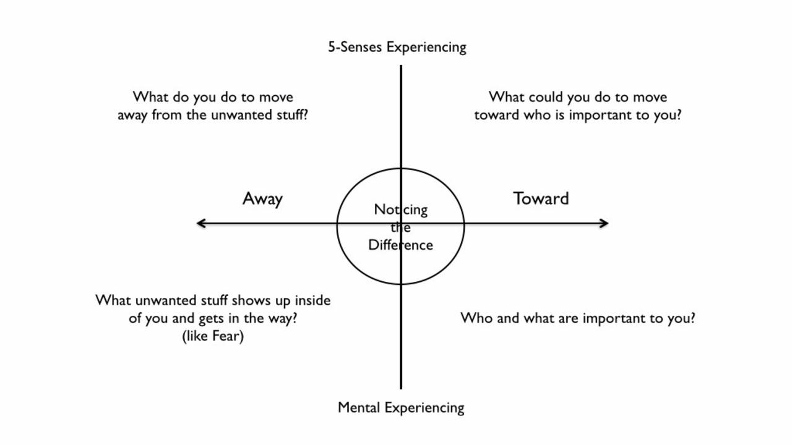
3.
4.
3
1.
2.
3
1.
2.
3
3.
4.
3
3.
4.
3
3.
4.
3

For example:
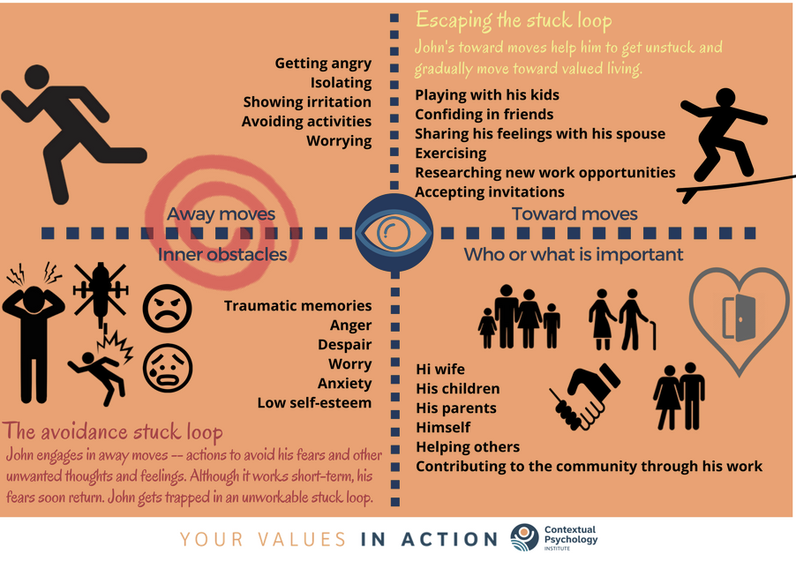
Taking ACTion Foundations: Part 2

Journal Exercise: Tug of War Exercise
In what ways does this metaphor relate to your own experience? Use the blank space below to type your response.

Journal Exercise: Mindfulness of the Moment Exercise
Reflect on your experience of practicing the mindfulness exercise. What was it like for you?

Practice
Mindfulness exercises I want to practice:

How often/how much time I will practice:

Reminders I will set for myself:

